Assignment 1
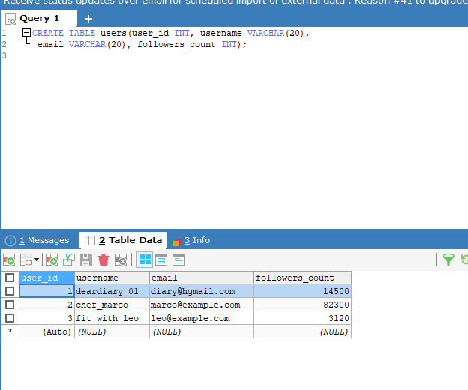
Create a new database called InstaClone in MySQL Workbench, then create a table named Users with columns: user_id (INT, primary key), username (VARCHAR), email (VARCHAR), and followers_count (INT).

Insert 3 sample users into the Users table you created, using realistic Instagram-style usernames and follower counts.
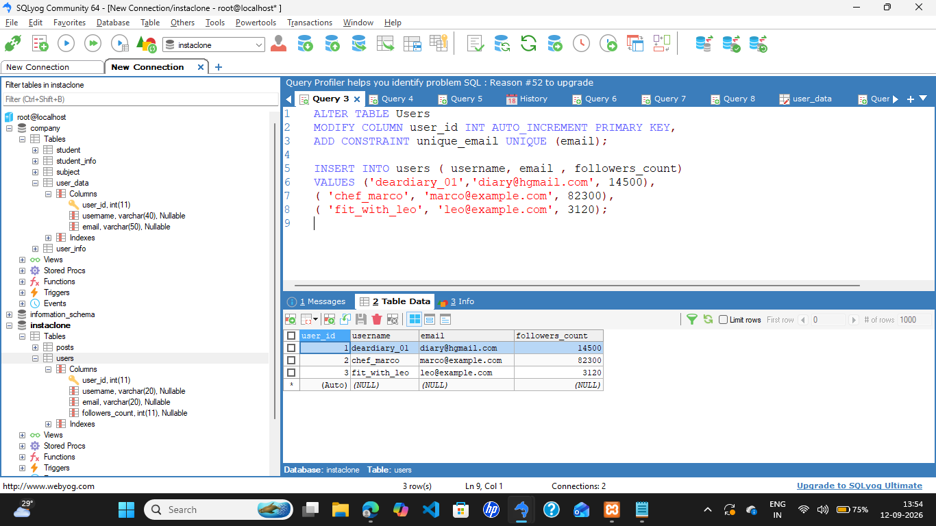

Create another table in the InstaClone database called Posts with columns: post_id (INT, primary key), user_id (INT), caption (VARCHAR), and post_date (DATE). Add a foreign key from Posts.user_id to Users. user_id to establish a relationship.

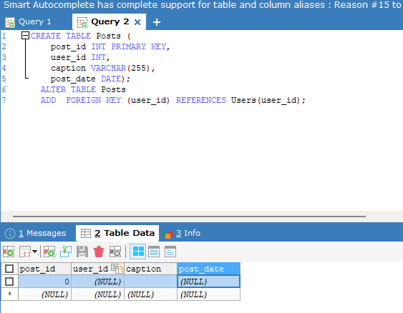

Write a short comparison (3-4 lines each) of MySQL, PostgreSQL, Oracle, and SQLite, focusing on where each one is commonly used (for example: web apps, mobile apps, enterprise systems, etc.).

MySQL
Widely utilized for web applications, content management systems, and SaaS platforms. It powers major internet architectures like WordPress and Shopify due to its speed and reliability in read-heavy application environments.
PostgreSQL
Commonly deployed for complex enterprise applications, data warehousing, and modern scalable web services. Its strong standard compliance, native support for advanced data types, and superior concurrent write handling make it a favorite for robust tech stacks.
Oracle
Heavily relied upon in mission-critical corporate environments, large banking systems, and massive enterprise architectures. It provides robust transactional integrity, advanced security features, and extensive scalability for high-stakes business operations.
SQLite
Extensively used for mobile applications (iOS and Android), local desktop software, and embedded IoT devices. Its serverless, self-contained architecture stores all data inside a single lightweight file without requiring a dedicated background server process

Assignment 2
Open MySQL Workbench or CLI and write a CREATE TABLE statement to create a table called 'restaurants' with columns: id (INT, primary key, auto-increment), name (VARCHAR(100)), location (VARCHAR(100)), and rating (DECIMAL(2,1)).
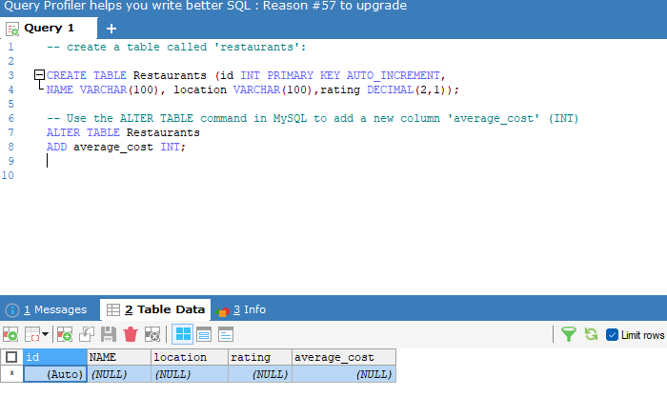
Use the ALTER TABLE command in MySQL to add a new column 'average_cost' (INT) to your 'restaurants' table. Hint: Remember to specify the data type when adding a new column.

Write a SQL statement to DROP the 'restaurants' table you created earlier. Double-check your command before running it to avoid accidental data loss.
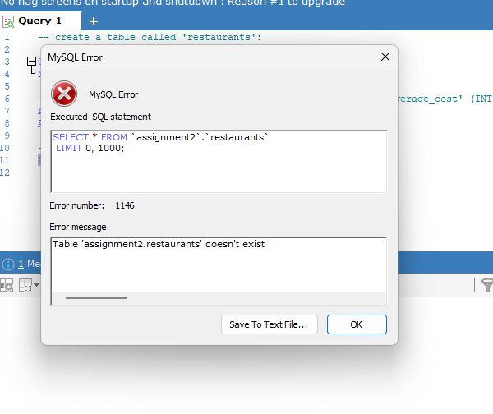

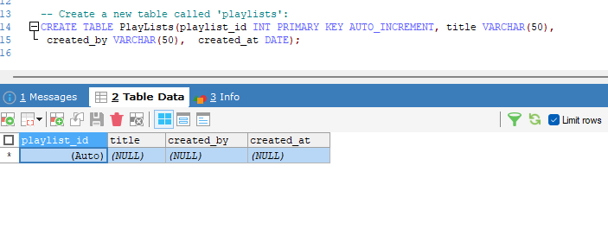
Create a new table called 'playlists' for a music app like Spotify, with columns: playlist_id (INT, primary key, auto-increment), title (VARCHAR(50)), created_by (VARCHAR(50)), and created_at (DATE).

